102 W. Pennsylvania Avenue
Suite 101
Towson, MD 21204
410-825-6200
410-821-9901 fax

www.baltcountycc.com
Helping small business owners achieve their dreams of ownership and success since 1983.

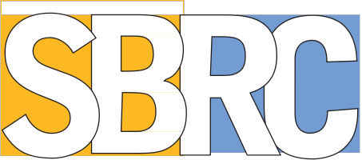www.baltimorecountymd.gov

Client Intake Form
Date:

First Name | MI | Last Name
Company Name |  | Personal Title
Address
- Home
- Business

City | State | ZIP
E-mail |  | Phone
Website  - Veteran  - Service Disabled Veteran |  | Cell Phone

Reason for meeting request: Additional Comments:
- Business Plan Assistance
- Loan Assistance
- Marketing Advice
- MBE Certification Assistance
- Other

How did you find out about SBRC?
- Library
- Advertising
- County Website
- Professional referral

The Baltimore County Small Business Resource Center (SBRC) is a cooperative effort between the Baltimore County
Chamber of Commerce and the Baltimore County Department of Economic Development.

